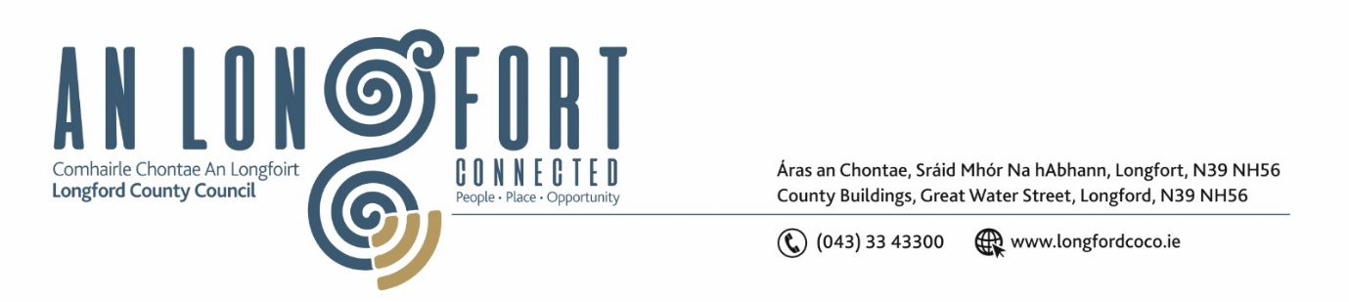**LONGFORD MUNICIPAL DISTRICT**

**Minutes of Meeting of Longford Municipal District**

**held in the Council Chamber Aras an Chontae and via MS Teams**

**on Wednesday, 24 January 2024 at 4pm**

**CATHAOIRLEACH**: Councillor Martin Monaghan

**MEMBERS PRESENT**: Councillors – Uruemu Adejinmi, John Browne, Seamus Butler, Peggy Nolan, Gerry Warnock, Gerry Hagan

**IN ATTENDANCE**: Mr. John Brannigan, Director of Services

Mr. Eamon Bennett, Senior Executive Engineer

Ms. Lorraine McKee, Administrative Officer

Mr. Richard Smith, Senior Executive Architect

**MEETINGS**

**ADMINISTRATOR:**  Ms. Claire McNabola

**APOLOGIES:**  None

1. **ADOPTION OF MINUTES – circulated**
2. On the proposal of Councillor Peggy Nolan seconded by Councillor Seamus Butler it was unanimously agreed to adopt Minutes of Meeting of Longford Municipal District held on Wednesday 22 November 2023, as circulated.
3. **MATTERS ARISING FROM MINUTES**

None

1. **DECLARATION OF INTEREST BY MEMBERS**

None.

1. **MANAGEMENT REPORT - circulated**

The Management Report, as circulated, was noted.

Councillor Gerry Warnock raised the matter of Lighting of black spots in the Mall, this was supported by Councillor Martin Monaghan. Eamon Bennett responded to say that he will meet with Gerry & Martin in the Mall and identify the areas and get a price from Electric Skyline for the works.

Councillor Seamus Butler raised the matter of huge amounts of rubbish dumped in Weavers Hall Carpark. This was supported by Councillor Martin Monaghan. John Brannigan replied to advise that notices have issued to residents & landlord in relation to the matter from the Environment Section and this will be followed up on.

Councillor Butler also raised his concern about the erecting of Provincial Flags on Lampposts and Flagpoles around the Town. John Brannigan replied to say the flags will all be removed.

Councillor Martin Monaghan asked why Eircom used tarmac to fill in around the new Grids on the footpaths on Ballinalee Road instead of concrete. Eamon Bennett replied to advise this was only a temporary solution and that Eircom would leave the footpaths as they were found.

1. **NOTICES OF MOTION, SUBMITTD BY COUNCILLORS, AS LISTED HEREUNDER:**

**The following notice of motion was proposed by Councillor Seamus Butler and seconded by Councillor Martin Monagan**

1. Due to frequent parking on the Ballinalee Road entrance to College Park causing difficult ingress and egress, I propose that double yellow lines be added from the Ballinalee Road at least 50m into College Park on each side of the road.

**Response – Eamon Bennett**

The double yellow lines on each side of the road in College Park will require bye-laws and public consultation. We are carrying out a review of the Longford Town bye-laws this year. We will include this item in the revised bye-laws.

**The following notice of motion was proposed by Councillor Seamus Butler and seconded by Councillor Martin Monaghan**

1. I propose that the Courthouse Alley off Main Street be taken in charge by Longford County Council, using a CPO if necessary.

**Response – John Brannigan**

Longford County Council have consulted with their Law Agent, maps have been requested to research the matter and a report will be issued to the Members.

**The following notice of motion was proposed by Councillor Gerry Hagan and seconded by Councillor Peggy Nolan**

I call on Longford MD to include the stretch of road (L1011), from Kiernan’s Forge Crossroads to the crossroads at Melview on the winter salting/gritting program.

**Response – Eamonn Bennett**

At the present time we do not have the resources to add additional routes to our winter salting programme.

**The following notice of motion was proposed by Councillor Martin Monaghan and seconded by Councillor Gerry Warnock, and supported by all Members**

1. I propose that the parking times be revised in Longford town from 9am to 5pm.I believe that this amendment to parking times would benefit businesses and the public.

**Response – Eamonn Bennett**

The proposed revision to the parking times will require bye-laws and public consultation. We are carrying out a review of the Longford Town bye-laws this year. We will include this item in the revised bye-laws.

**The following notice of motion was proposed by Councillor Martin Monaghan and seconded by Councillor Seamus Butler**

1. That the manhole covers on the east side of the Market Square at the junction with Earl Street be made level with the road surface.

**Response – Eamonn Bennett**

The issue here is not the manhole covers but rather the road surface is not at the required levels to match the manholes. The reason the manholes are higher than the road is that contractors carried out numerous repairs at this location and settlement in the roadway has left the manhole covers above the road surface.

**CORRESPONDENCE**

1. The correspondence received from Uisce Eireann on 29 November 2023 in relation to the Taking in Charge of infrastructure in Cartrun Breac Estate, was noted.

This concluded the business of the meeting.

**Signed: ____________________**

**Claire McNabola,**

**Meetings Administrator.**

**Confirmed and adopted at Longford Municipal District Meeting held on the 21 February 2024.**

**Signed: _______________**

**Cathaoirleach**